Spring REST using Spring Boot 3

Spring-rest-handson

Create a Spring Web Project using Maven

//SpringLearnApplication.java
package com.cognizant.spring_learn;

import org.springframework.boot.SpringApplication;
import org.springframework.boot.autoconfigure.SpringBootApplication;

@SpringBootApplication
public class SpringLearnApplication {

public static void main(String[] args) {
System.out.println("LOGGING");
System.out.println("Application Starting...");
System.out.println();

SpringApplication.run(SpringLearnApplication.class, args);

System.out.println("LOGGING");
System.out.println("Application Started Successfully.");
System.out.println();
}

}

//SpringLearnApplicationTest.java

package com.cognizant.spring_learn;

import org.springframework.boot.SpringApplication;
import org.springframework.boot.autoconfigure.SpringBootApplication;

@SpringBootApplication
public class SpringLearnApplication {

public static void main(String[] args) {
System.out.println("LOGGING");
System.out.println("Application Starting...");
System.out.println();

SpringApplication.run(SpringLearnApplication.class, args);

System.out.println("LOGGING");
System.out.println("Application Started Successfully.");
System.out.println();
}

}

//pom.xml

<?xml version="1.0" encoding="UTF-8"?>
<project xmlns="http://maven.apache.org/POM/4.0.0" xmlns:xsi="http://www.w3.org/2001/XMLSchema-instance"
xsi:schemaLocation="http://maven.apache.org/POM/4.0.0 https://maven.apache.org/xsd/maven-4.0.0.xsd">
<modelVersion>4.0.0</modelVersion>
<parent>
<groupId>org.springframework.boot</groupId>
<artifactId>spring-boot-starter-parent</artifactId>
<version>3.5.3</version>
<relativePath/> <!-- lookup parent from repository -->
</parent>
<groupId>com.cognizant</groupId>
<artifactId>spring-learn</artifactId>
<version>0.0.1-SNAPSHOT</version>
<name>spring-learn</name>
<description>Demo project for Spring Boot</description>
<url/>
<licenses>
<license/>
</licenses>
<developers>
<developer/>
</developers>
<scm>
<connection/>
<developerConnection/>
<tag/>
<url/>
</scm>
<properties>
<java.version>21</java.version>
</properties>
<dependencies>
<dependency>
<groupId>org.springframework.boot</groupId>
<artifactId>spring-boot-starter-web</artifactId>
</dependency>

<dependency>
<groupId>org.springframework.boot</groupId>
<artifactId>spring-boot-devtools</artifactId>
<scope>runtime</scope>
<optional>true</optional>
</dependency>
<dependency>
<groupId>org.springframework.boot</groupId>
<artifactId>spring-boot-starter-test</artifactId>
<scope>test</scope>
</dependency>
</dependencies>

<build>
<plugins>
<plugin>
<groupId>org.springframework.boot</groupId>
<artifactId>spring-boot-maven-plugin</artifactId>
</plugin>
</plugins>
</build>

</project>
OUTPUT:
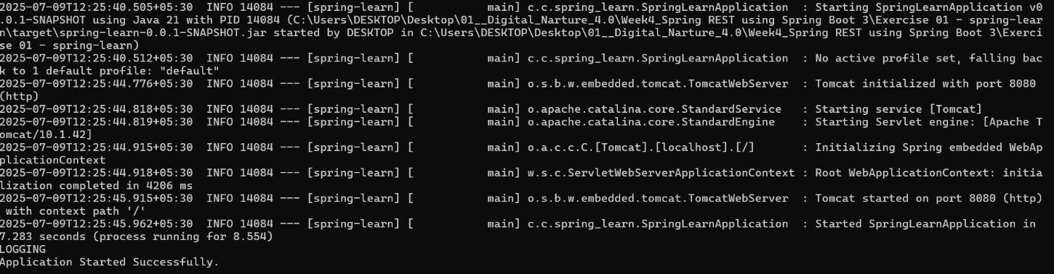
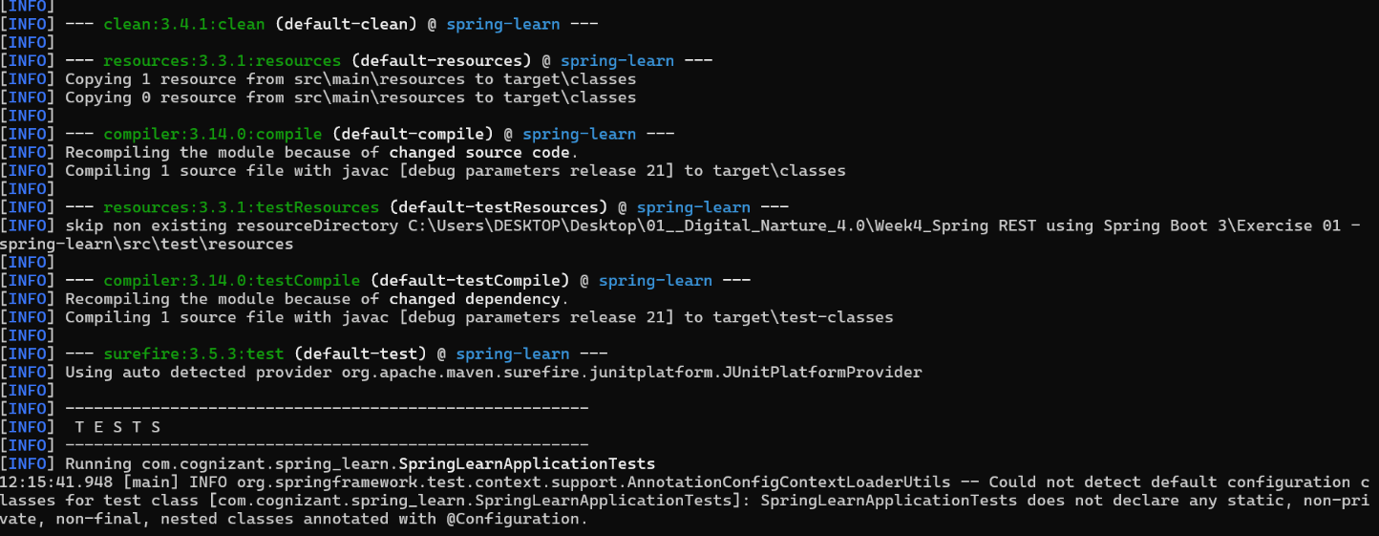
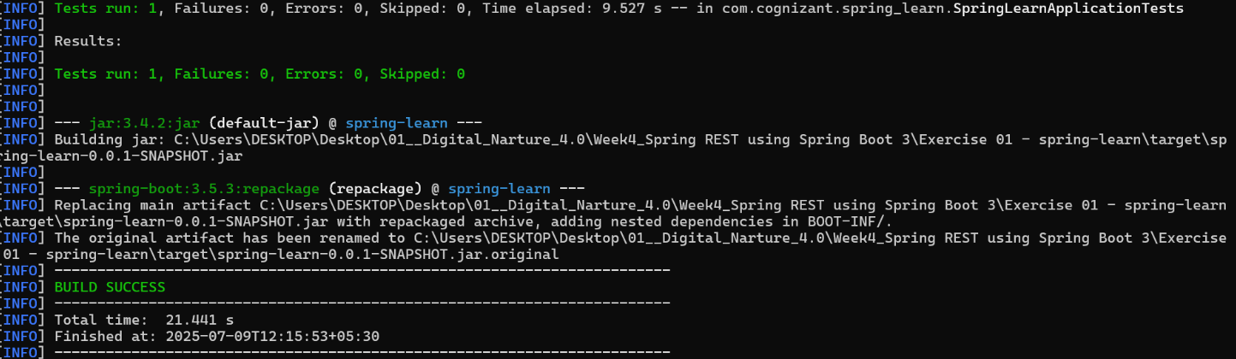

Spring Core – Load Country from Spring Configuration XML

//Country.java
package com.cognizant.springlearn;

import org.slf4j.Logger;
import org.slf4j.LoggerFactory;

public class Country {
private static final Logger LOGGER = LoggerFactory.getLogger(Country.class);

private String code;
private String name;

public Country() {
LOGGER.debug("Inside Country Constructor.");
}

public String getCode() {
LOGGER.debug("Inside getCode()");
return code;
}

public void setCode(String code) {
LOGGER.debug("Inside setCode()");
this.code = code;
}

public String getName() {
LOGGER.debug("Inside getName()");
return name;
}

public void setName(String name) {
LOGGER.debug("Inside setName()");
this.name = name;
}

@Override
public String toString() {
return "Country{" +
"code='" + code + '\'' +
", name='" + name + '\'' +
'}';
}
}

//SpringLearnApplication.java
package com.cognizant.springlearn;

import org.slf4j.Logger;
import org.slf4j.LoggerFactory;
import org.springframework.context.ApplicationContext;
import org.springframework.context.support.ClassPathXmlApplicationContext;

public class SpringLearnApplication {

private static final Logger LOGGER = LoggerFactory.getLogger(SpringLearnApplication.class);

public static void main(String[] args) {
displayCountry();
}

public static void displayCountry() {
ApplicationContext context = new ClassPathXmlApplicationContext("country.xml");

Country country = (Country) context.getBean("country");
LOGGER.debug("Country : {}", country.toString());
}
}

//Country.xml
<?xml version="1.0" encoding="UTF-8"?>
<beans xmlns="http://www.springframework.org/schema/beans"
xmlns:xsi="http://www.w3.org/2001/XMLSchema-instance"
xsi:schemaLocation="http://www.springframework.org/schema/beans
http://www.springframework.org/schema/beans/spring-beans.xsd">

<bean id="country" class="com.cognizant.springlearn.Country">
<property name="code" value="IN" />
<property name="name" value="India" />
</bean>

</beans>

//pom.xml
<?xml version="1.0" encoding="UTF-8"?>
<project xmlns="http://maven.apache.org/POM/4.0.0"
xmlns:xsi="http://www.w3.org/2001/XMLSchema-instance"
xsi:schemaLocation="http://maven.apache.org/POM/4.0.0 http://maven.apache.org/xsd/maven-4.0.0.xsd">
<modelVersion>4.0.0</modelVersion>

<groupId>com.cognizant.springlearn</groupId>
<artifactId>SpringCore_LoadCountry_from_SpringConfigurationXML</artifactId>
<version>1.0-SNAPSHOT</version>

<properties>
<maven.compiler.source>21</maven.compiler.source>
<maven.compiler.target>21</maven.compiler.target>
<project.build.sourceEncoding>UTF-8</project.build.sourceEncoding>
</properties>

<dependencies>
<!-- https://mvnrepository.com/artifact/org.springframework/spring-context -->
<dependency>
<groupId>org.springframework</groupId>
<artifactId>spring-context</artifactId>
<version>7.0.0-M6</version>
</dependency>

<!-- SLF4J and Logback for Logging -->
<!-- https://mvnrepository.com/artifact/org.slf4j/slf4j-api -->
<dependency>
<groupId>org.slf4j</groupId>
<artifactId>slf4j-api</artifactId>
<version>2.1.0-alpha1</version>
</dependency>

<!-- https://mvnrepository.com/artifact/ch.qos.logback/logback-classic -->
<dependency>
<groupId>ch.qos.logback</groupId>
<artifactId>logback-classic</artifactId>
<version>1.5.18</version>
<scope>compile</scope>
</dependency>
</dependencies>

</project>

OUTPUT:
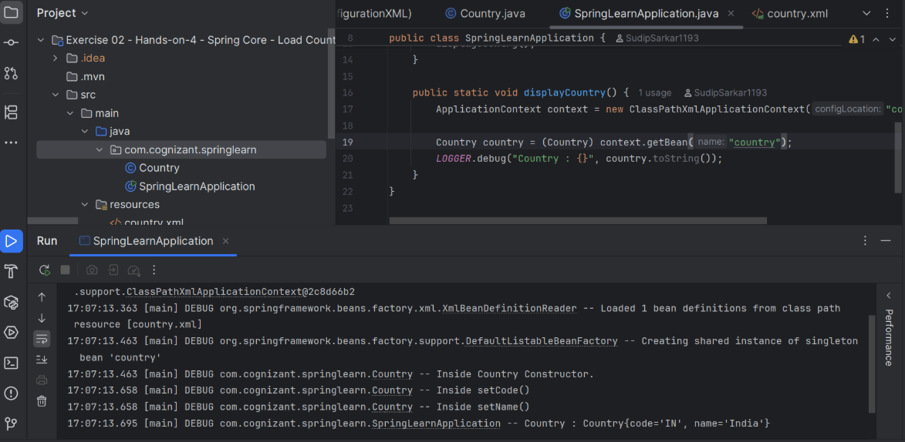

Hello World RESTful Web Service

//HelloController.java

package com.cognizant.springlearn.controller;

import org.slf4j.Logger;
import org.slf4j.LoggerFactory;
import org.springframework.web.bind.annotation.GetMapping;
import org.springframework.web.bind.annotation.RequestMapping;
import org.springframework.web.bind.annotation.RestController;

@RestController
@RequestMapping("/hello")
public class HelloController {

private static final Logger LOGGER = LoggerFactory.getLogger(HelloController.class);

@GetMapping
public String sayHello() {
LOGGER.info("Start of sayHello method");
String response = "Hello World!!";
LOGGER.info("End of sayHello method");
return response;
}
}

//HelloWorldResTfulWebServiceApplication.java

package com.cognizant.springlearn;
import org.springframework.boot.SpringApplication;
import org.springframework.boot.autoconfigure.SpringBootApplication;

@SpringBootApplication
public class HelloWorldResTfulWebServiceApplication {

public static void main(String[] args) {
SpringApplication.run(HelloWorldResTfulWebServiceApplication.class, args);
}
}
//HelloWorldResTfulWebServiceApplicationTests.java

package com.cognizant.springlearn;

import org.junit.jupiter.api.Test;
import org.springframework.boot.test.context.SpringBootTest;

@SpringBootTest
class HelloWorldResTfulWebServiceApplicationTests {

@Test
void contextLoads() {
}

}

//pom.xml
<?xml version="1.0" encoding="UTF-8"?>
<project xmlns="http://maven.apache.org/POM/4.0.0" xmlns:xsi="http://www.w3.org/2001/XMLSchema-instance"
xsi:schemaLocation="http://maven.apache.org/POM/4.0.0 https://maven.apache.org/xsd/maven-4.0.0.xsd">
<modelVersion>4.0.0</modelVersion>
<parent>
<groupId>org.springframework.boot</groupId>
<artifactId>spring-boot-starter-parent</artifactId>
<version>3.5.3</version>
<relativePath/> <!-- lookup parent from repository -->
</parent>
<groupId>com.cognizant.springlearn</groupId>
<artifactId>HelloWorld_RESTfulWebService</artifactId>
<version>0.0.1-SNAPSHOT</version>
<name>Hello World RESTful Web Service</name>
<description>Demo project for Spring REST</description>
<url/>
<licenses>
<license/>
</licenses>
<developers>
<developer/>
</developers>
<scm>
<connection/>
<developerConnection/>
<tag/>
<url/>
</scm>
<properties>
<java.version>21</java.version>
</properties>
<dependencies>
<dependency>
<groupId>org.springframework.boot</groupId>
<artifactId>spring-boot-starter-web</artifactId>
</dependency>

<dependency>
<groupId>org.springframework.boot</groupId>
<artifactId>spring-boot-starter-test</artifactId>
<scope>test</scope>
</dependency>
</dependencies>

<build>
<plugins>
<plugin>
<groupId>org.springframework.boot</groupId>
<artifactId>spring-boot-maven-plugin</artifactId>
</plugin>
</plugins>
</build>

</project>

OUTPUT:
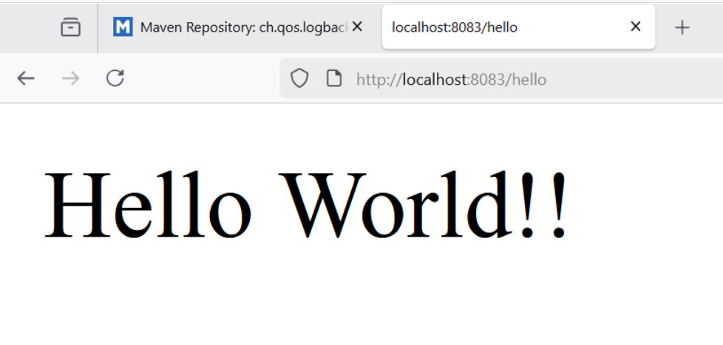
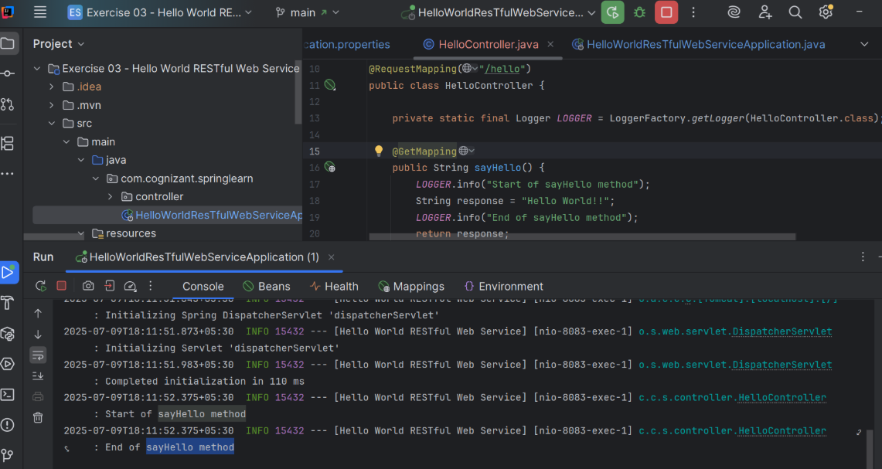

REST - Country Web Service

//CountryController.java
package com.cognizant.springlearn.controller;

import com.cognizant.springlearn.model.Country;
import org.springframework.context.ApplicationContext;
import org.springframework.context.support.ClassPathXmlApplicationContext;
import org.springframework.web.bind.annotation.RequestMapping;
import org.springframework.web.bind.annotation.RestController;

@RestController
public class CountryController {

@RequestMapping("/country")
public Country getCountryIndia() {
// Load the Spring XML configuration
ApplicationContext context = new ClassPathXmlApplicationContext("applicationContext.xml");
// Get the India bean
Country country = (Country) context.getBean("india");
return country;
}
}

//Country.java

package com.cognizant.springlearn.model;

public class Country {
private String code;
private String name;

// Default constructor
public Country() {
}

// Parameterized constructor
public Country(String code, String name) {
this.code = code;
this.name = name;
}

// Getters and Setters
public String getCode() {
return code;
}

public void setCode(String code) {
this.code = code;
}

public String getName() {
return name;
}

public void setName(String name) {
this.name = name;
}
}

//RestCountryWebServiceApplication.java

package com.cognizant.springlearn;
import org.springframework.boot.SpringApplication;
import org.springframework.boot.autoconfigure.SpringBootApplication;

@SpringBootApplication
public class RestCountryWebServiceApplication {

public static void main(String[] args) {
SpringApplication.run(RestCountryWebServiceApplication.class, args);
}

}
//applicationContext.xml

<?xml version="1.0" encoding="UTF-8"?>
<beans xmlns="http://www.springframework.org/schema/beans"
xmlns:xsi="http://www.w3.org/2001/XMLSchema-instance"
xsi:schemaLocation="http://www.springframework.org/schema/beans
http://www.springframework.org/schema/beans/spring-beans.xsd">

<bean id="india" class="com.cognizant.springlearn.model.Country">
<property name="code" value="IN"/>
<property name="name" value="India"/>
</bean>

</beans>

//RestCountryWebServiceApplicationTests.java

package com.cognizant.springlearn;
import org.junit.jupiter.api.Test;
import org.springframework.boot.test.context.SpringBootTest;

@SpringBootTest
class RestCountryWebServiceApplicationTests {

@Test
void contextLoads() {
}

}
//pom.xml

<?xml version="1.0" encoding="UTF-8"?>
<project xmlns="http://maven.apache.org/POM/4.0.0"
xmlns:xsi="http://www.w3.org/2001/XMLSchema-instance"
xsi:schemaLocation="http://maven.apache.org/POM/4.0.0 http://maven.apache.org/xsd/maven-4.0.0.xsd">
<modelVersion>4.0.0</modelVersion>

<groupId>com.cognizant</groupId>
<artifactId>spring-learn</artifactId>
<version>0.0.1-SNAPSHOT</version>
<name>RestCountryWebService</name>
<description>REST Country Web Service</description>

<parent>
<groupId>org.springframework.boot</groupId>
<artifactId>spring-boot-starter-parent</artifactId>
<version>3.5.3</version>
<relativePath/> <!-- lookup parent from repository -->
</parent>

<properties>
<java.version>21</java.version>
</properties>

<dependencies>
<dependency>
<groupId>org.springframework.boot</groupId>
<artifactId>spring-boot-starter-web</artifactId>
</dependency>
<dependency>
<groupId>org.springframework</groupId>
<artifactId>spring-context</artifactId>
</dependency>
</dependencies>

<build>
<plugins>
<plugin>
<groupId>org.springframework.boot</groupId>
<artifactId>spring-boot-maven-plugin</artifactId>
</plugin>
</plugins>
</build>

</project>

OUTPUT:
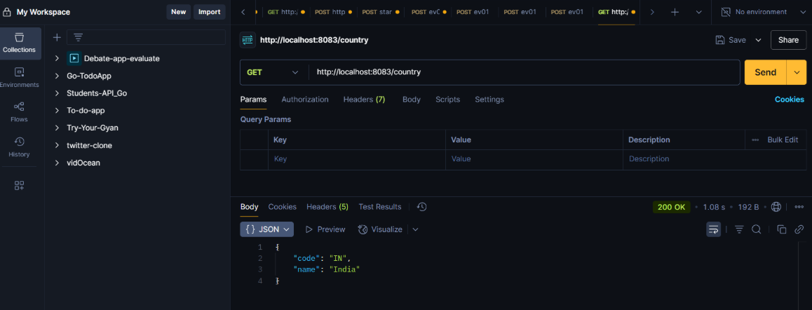

REST - Get country based on country code

//CountryController.java
package com.cognizant.springlearn.controller;

import java.util.List;

import org.slf4j.Logger;
import org.slf4j.LoggerFactory;
import org.springframework.beans.factory.annotation.Autowired;
import org.springframework.http.HttpStatus;
import org.springframework.http.ResponseEntity;
import org.springframework.web.bind.annotation.GetMapping;
import org.springframework.web.bind.annotation.PathVariable;
import org.springframework.web.bind.annotation.RestController;

import com.cognizant.springlearn.model.Country;
import com.cognizant.springlearn.service.CountryService;

/**
* Country REST Controller
*
* Controller: com.cognizant.spring-learn.controller.CountryController
* Demonstrates RESTful Web Service for getting country by country code
*/
@RestController
public class CountryController {

private static final Logger logger = LoggerFactory.getLogger(CountryController.class);

@Autowired
private CountryService countryService;

/**
* REST service that returns a specific country based on country code
* The country code should be case insensitive
*
* Controller: com.cognizant.spring-learn.controller.CountryController
* Method Annotation: @GetMapping("/countries/{code}")
* Method Name: getCountry(String code)
* Method Implementation: Invoke countryService.getCountry(code)
*
* Service Method Implementation:
* • Get the country code using @PathVariable
* • Get country list from country.xml
* • Iterate through the country list
* • Make a case insensitive matching of country code and return the country
* • Lambda expression is used instead of iterating the country list
*
* Sample Request: http://localhost:8083/countries/in
* Sample Response: { "code": "IN", "name": "India" }
*
* @param code Country code (case insensitive)
* @return Country object if found, 404 if not found
*/
@GetMapping("/countries/{code}")
public ResponseEntity<Country> getCountry(@PathVariable String code) {
logger.info("START - getCountry() method called with PathVariable code: {}", code);
logger.info("Processing GET request for /countries/{} endpoint", code);

// Invoke countryService.getCountry(code)
Country country = countryService.getCountry(code);

if (country != null) {
logger.info("Country found and returning: {}", country);
logger.info("END - getCountry() method completed - Returning: {}", country);
return ResponseEntity.ok(country);
} else {
logger.warn("Country not found for code: {}", code);
logger.info("END - getCountry() method completed - Returning: 404 Not Found");
return ResponseEntity.status(HttpStatus.NOT_FOUND).body(null);
}
}

/**
* Get all countries endpoint for testing purposes
*
* @return List of all countries
*/
@GetMapping("/countries")
public ResponseEntity<List<Country>> getAllCountries() {
logger.info("START - getAllCountries() method called");
logger.info("Processing GET request for /countries endpoint");

List<Country> countries = countryService.getAllCountries();

logger.info("Returning {} countries", countries.size());
logger.info("END - getAllCountries() method completed");

return ResponseEntity.ok(countries);
}

/**
* Simple home endpoint
*
* @return Welcome message
*/
@GetMapping("/")
public String home() {
logger.info("Home endpoint accessed");
return "Welcome to Country Code REST Service! " +
"Use /countries/{code} to get a specific country by code. " +
"Example: /countries/in for India";
}

/**
* Health check endpoint
*
* @return Health status
*/
@GetMapping("/health")
public String health() {
logger.info("Health check endpoint accessed");
return "Country Code REST Service is UP and running on port 8083!";
}
}

//Country.java
package com.cognizant.springlearn.model;

/**
* Country Model Class
* Represents a country with code and name
*/
public class Country {

private String code;
private String name;

// Default constructor
public Country() {
}

// Parameterized constructor
public Country(String code, String name) {
this.code = code;
this.name = name;
}

// Getters and Setters
public String getCode() {
return code;
}

public void setCode(String code) {
this.code = code;
}

public String getName() {
return name;
}

public void setName(String name) {
this.name = name;
}

@Override
public String toString() {
return "Country{" +
"code='" + code + '\'' +
", name='" + name + '\'' +
'}';
}

@Override
public boolean equals(Object obj) {
if (this == obj) return true;
if (obj == null || getClass() != obj.getClass()) return false;
Country country = (Country) obj;
return code != null ? code.equalsIgnoreCase(country.code) : country.code == null;
}

@Override
public int hashCode() {
return code != null ? code.toUpperCase().hashCode() : 0;
}
}

//CountryService.java

package com.cognizant.springlearn.service;

import java.util.List;
import java.util.Optional;

import org.slf4j.Logger;
import org.slf4j.LoggerFactory;
import org.springframework.context.support.ClassPathXmlApplicationContext;
import org.springframework.stereotype.Service;

import com.cognizant.springlearn.model.Country;

/**
* Country Service Class
* Service Method: com.cognizant.spring-learn.service.CountryService.getCountry(String code)
* Handles business logic for country operations
*/
@Service
public class CountryService {

private static final Logger logger = LoggerFactory.getLogger(CountryService.class);

/**
* Service Method Implementation:
* • Get country list from country.xml
* • Iterate through the country list
* • Make a case insensitive matching of country code and return the country
* • Lambda expression is used instead of iterating the country list
*
* @param code Country code (case insensitive)
* @return Country object if found, null otherwise
*/
@SuppressWarnings("unchecked")
public Country getCountry(String code) {
logger.info("START - getCountry() method called with code: {}", code);

if (code == null || code.trim().isEmpty()) {
logger.warn("Country code is null or empty");
return null;
}

String upperCaseCode = code.toUpperCase().trim();
logger.info("Searching for country with code: {} (original: {})", upperCaseCode, code);

try {
// Get country list from country.xml
logger.info("Loading country list from country.xml");
try (ClassPathXmlApplicationContext context = new ClassPathXmlApplicationContext("country.xml")) {
List<Country> countries = (List<Country>) context.getBean("countryList");

logger.info("Successfully loaded {} countries from XML configuration", countries.size());

// Lambda expression for case insensitive matching of country code
Optional<Country> foundCountry = countries.stream()
.filter(country -> country.getCode() != null &&
country.getCode().equalsIgnoreCase(upperCaseCode))
.findFirst();

if (foundCountry.isPresent()) {
Country country = foundCountry.get();
logger.info("Country found: {}", country);
logger.info("END - getCountry() method completed - Returning: {}", country);
return country;
} else {
logger.warn("No country found with code: {}", upperCaseCode);
logger.info("END - getCountry() method completed - Returning: null");
return null;
}
}

} catch (Exception e) {
logger.error("Error in getCountry() method: " + e.getMessage());
logger.info("END - getCountry() method completed with error - Returning: null");
return null;
}
}

/**
* Get all countries from XML configuration
* Helper method for demonstration purposes
*
* @return List of all countries
*/
@SuppressWarnings("unchecked")
public List<Country> getAllCountries() {
logger.info("START - getAllCountries() method called");

try {
logger.info("Loading all countries from country.xml");
try (ClassPathXmlApplicationContext context = new ClassPathXmlApplicationContext("country.xml")) {
List<Country> countries = (List<Country>) context.getBean("countryList");

logger.info("Successfully loaded {} countries", countries.size());
logger.info("END - getAllCountries() method completed");

return countries;
}

} catch (Exception e) {
logger.error("Error in getAllCountries() method: " + e.getMessage());
return List.of(); // Return empty list on error
}
}
}

//CountryCodeRestServiceApplication.java

package com.cognizant.springlearn;

import org.slf4j.Logger;
import org.slf4j.LoggerFactory;
import org.springframework.boot.SpringApplication;
import org.springframework.boot.autoconfigure.SpringBootApplication;

/**
* Main Spring Boot Application Class for Country Code REST Service
*/
@SpringBootApplication
public class CountryCodeRestServiceApplication {

private static final Logger logger = LoggerFactory.getLogger(CountryCodeRestServiceApplication.class);

public static void main(String[] args) {
logger.info("=================================================================");
logger.info("Starting Country Code RESTful Web Service Application...");
logger.info("=================================================================");

// Start the Spring Boot application
SpringApplication.run(CountryCodeRestServiceApplication.class, args);

logger.info("=================================================================");
logger.info("Country Code REST Service Application started successfully!");
logger.info("Application is running on: http://localhost:8083");
logger.info("Country endpoints:");
logger.info(" - Get Country by Code: http://localhost:8083/countries/{code}");
logger.info(" - Example: http://localhost:8083/countries/in");
logger.info(" - All Countries: http://localhost:8083/countries");
logger.info(" - Health Check: http://localhost:8083/health");
logger.info("=================================================================");
}
}

//index.html

<!DOCTYPE html>
<html lang="en">
<head>
<meta charset="UTF-8">
<meta name="viewport" content="width=device-width, initial-scale=1.0">
<title>Country Code REST Service</title>
<style>
body { font-family: Arial, sans-serif; margin: 40px; }
.container { max-width: 800px; margin: 0 auto; }
.endpoint { background: #f5f5f5; padding: 15px; margin: 10px 0; border-radius: 5px; }
.method { background: #28a745; color: white; padding: 5px 10px; border-radius: 3px; }
.url { font-family: monospace; background: #e9ecef; padding: 5px; border-radius: 3px; }
.example { background: #d1ecf1; padding: 10px; border-radius: 3px; margin: 10px 0; }
.code { background: #f8f9fa; border: 1px solid #dee2e6; padding: 10px; border-radius: 3px; }
</style>
</head>
<body>
<div class="container">
<h1>Country Code REST Service</h1>
<p>Welcome to the Country Code REST Service! This service allows you to get country details by country code with case-insensitive matching.</p>

<h2>Main Endpoint:</h2>

<div class="endpoint">
<h3>Get Country by Code (Case Insensitive)</h3>
<p><span class="method">GET</span> <span class="url">/countries/{code}</span></p>
<p><strong>Description:</strong> Returns a specific country based on country code. The country code matching is case insensitive.</p>

<div class="example">
<h4>Examples:</h4>
<ul>
<li><a href="/countries/in" target="_blank">http://localhost:8083/countries/in</a> (lowercase)</li>
<li><a href="/countries/IN" target="_blank">http://localhost:8083/countries/IN</a> (uppercase)</li>
<li><a href="/countries/Us" target="_blank">http://localhost:8083/countries/Us</a> (mixed case)</li>
<li><a href="/countries/jp" target="_blank">http://localhost:8083/countries/jp</a> (Japan)</li>
<li><a href="/countries/de" target="_blank">http://localhost:8083/countries/de</a> (Germany)</li>
<li><a href="/countries/gb" target="_blank">http://localhost:8083/countries/gb</a> (United Kingdom)</li>
<li><a href="/countries/fr" target="_blank">http://localhost:8083/countries/fr</a> (France)</li>
<li><a href="/countries/ca" target="_blank">http://localhost:8083/countries/ca</a> (Canada)</li>
<li><a href="/countries/au" target="_blank">http://localhost:8083/countries/au</a> (Australia)</li>
</ul>
</div>

<p><strong>Sample Response for India (in/IN/In):</strong></p>
<div class="code">
<pre>{
"code": "IN",
"name": "India"
}</pre>
</div>
</div>

<h2>Additional Endpoints:</h2>

<div class="endpoint">
<h3>Get All Countries</h3>
<p><span class="method">GET</span> <span class="url">/countries</span></p>
<p>Returns all available countries</p>
<p><strong>URL:</strong> <a href="/countries" target="_blank">http://localhost:8083/countries</a></p>
</div>

<div class="endpoint">
<h3>Health Check</h3>
<p><span class="method">GET</span> <span class="url">/health</span></p>
<p>Service health check endpoint</p>
<p><strong>URL:</strong> <a href="/health" target="_blank">http://localhost:8083/health</a></p>
</div>

<h2>Implementation Details:</h2>
<ul>
<li><strong>Controller:</strong> com.cognizant.spring-learn.controller.CountryController</li>
<li><strong>Method Annotation:</strong> @GetMapping("/countries/{code}")</li>
<li><strong>Method Name:</strong> getCountry(String code)</li>
<li><strong>Service Method:</strong> com.cognizant.spring-learn.service.CountryService.getCountry(String code)</li>
<li><strong>Path Variable:</strong> Country code obtained using @PathVariable</li>
<li><strong>Data Source:</strong> Countries loaded from country.xml Spring configuration</li>
<li><strong>Matching:</strong> Case insensitive country code matching using Lambda expressions</li>
<li><strong>Response:</strong> Returns 200 OK with country details, or 404 Not Found if country doesn't exist</li>
</ul>

<h2>Available Country Codes:</h2>
<div class="code">
IN - India<br>
US - United States<br>
JP - Japan<br>
DE - Germany<br>
GB - United Kingdom<br>
FR - France<br>
CA - Canada<br>
AU - Australia
</div>
</div>
</body>
</html>

//Country.xml

<?xml version="1.0" encoding="UTF-8"?>
<beans xmlns="http://www.springframework.org/schema/beans"
xmlns:xsi="http://www.w3.org/2001/XMLSchema-instance"
xmlns:util="http://www.springframework.org/schema/util"
xsi:schemaLocation="http://www.springframework.org/schema/beans
http://www.springframework.org/schema/beans/spring-beans.xsd
http://www.springframework.org/schema/util
http://www.springframework.org/schema/util/spring-util.xsd">

<!-- Individual Country Beans -->
<bean id="india" class="com.cognizant.springlearn.model.Country">
<property name="code" value="IN"/>
<property name="name" value="India"/>
</bean>

<bean id="usa" class="com.cognizant.springlearn.model.Country">
<property name="code" value="US"/>
<property name="name" value="United States"/>
</bean>

<bean id="japan" class="com.cognizant.springlearn.model.Country">
<property name="code" value="JP"/>
<property name="name" value="Japan"/>
</bean>

<bean id="germany" class="com.cognizant.springlearn.model.Country">
<property name="code" value="DE"/>
<property name="name" value="Germany"/>
</bean>

<bean id="uk" class="com.cognizant.springlearn.model.Country">
<property name="code" value="GB"/>
<property name="name" value="United Kingdom"/>
</bean>

<bean id="france" class="com.cognizant.springlearn.model.Country">
<property name="code" value="FR"/>
<property name="name" value="France"/>
</bean>

<bean id="canada" class="com.cognizant.springlearn.model.Country">
<property name="code" value="CA"/>
<property name="name" value="Canada"/>
</bean>

<bean id="australia" class="com.cognizant.springlearn.model.Country">
<property name="code" value="AU"/>
<property name="name" value="Australia"/>
</bean>

<!-- Country List Configuration -->
<util:list id="countryList" value-type="com.cognizant.springlearn.model.Country">
<ref bean="india"/>
<ref bean="usa"/>
<ref bean="japan"/>
<ref bean="germany"/>
<ref bean="uk"/>
<ref bean="france"/>
<ref bean="canada"/>
<ref bean="australia"/>
</util:list>

</beans>

//CountryCodeRestServiceApplicationTests.java

package com.cognizant.springlearn;

import org.junit.jupiter.api.Test;
import org.springframework.boot.test.context.SpringBootTest;

@SpringBootTest
class CountryCodeRestServiceApplicationTests {

@Test
void contextLoads() {
}

}

//pom.xml

<?xml version="1.0" encoding="UTF-8"?>
<project xmlns="http://maven.apache.org/POM/4.0.0" xmlns:xsi="http://www.w3.org/2001/XMLSchema-instance"
xsi:schemaLocation="http://maven.apache.org/POM/4.0.0 https://maven.apache.org/xsd/maven-4.0.0.xsd">
<modelVersion>4.0.0</modelVersion>
<parent>
<groupId>org.springframework.boot</groupId>
<artifactId>spring-boot-starter-parent</artifactId>
<version>3.2.0</version>
<relativePath/> <!-- lookup parent from repository -->
</parent>
<groupId>com.cognizant</groupId>
<artifactId>country-code-rest-service</artifactId>
<version>0.0.1-SNAPSHOT</version>
<name>country-code-rest-service</name>
<description>REST Service to get country by country code using Spring Boot</description>
<properties>
<java.version>17</java.version>
</properties>
<dependencies>
<!-- Spring Boot Starter Web -->
<dependency>
<groupId>org.springframework.boot</groupId>
<artifactId>spring-boot-starter-web</artifactId>
</dependency>

<!-- Spring Boot DevTools -->
<dependency>
<groupId>org.springframework.boot</groupId>
<artifactId>spring-boot-devtools</artifactId>
<scope>runtime</scope>
<optional>true</optional>
</dependency>

<!-- Jackson for JSON processing -->
<dependency>
<groupId>com.fasterxml.jackson.core</groupId>
<artifactId>jackson-databind</artifactId>
</dependency>

<!-- Spring Boot Test Starter -->
<dependency>
<groupId>org.springframework.boot</groupId>
<artifactId>spring-boot-starter-test</artifactId>
<scope>test</scope>
</dependency>
</dependencies>

<build>
<plugins>
<plugin>
<groupId>org.springframework.boot</groupId>
<artifactId>spring-boot-maven-plugin</artifactId>
</plugin>
</plugins>
</build>

</project>

OUTPUT:
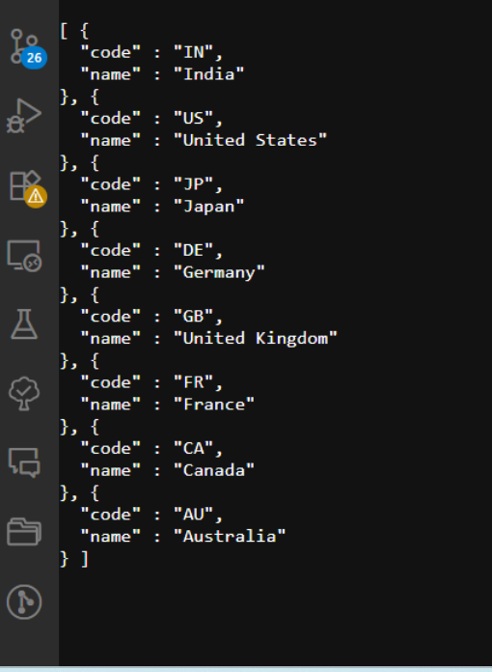
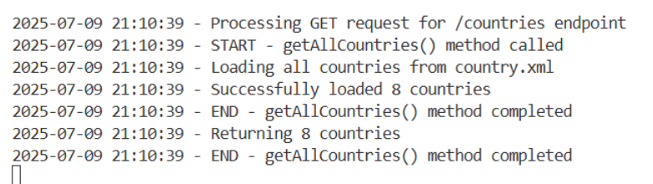
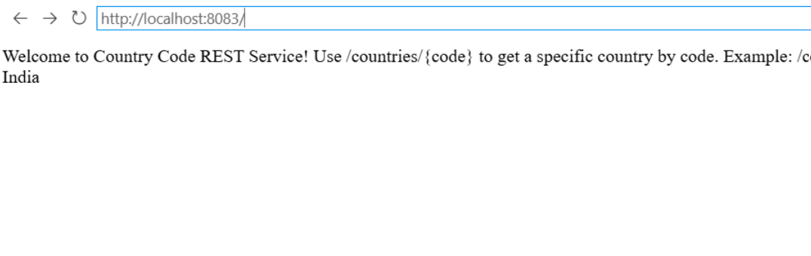
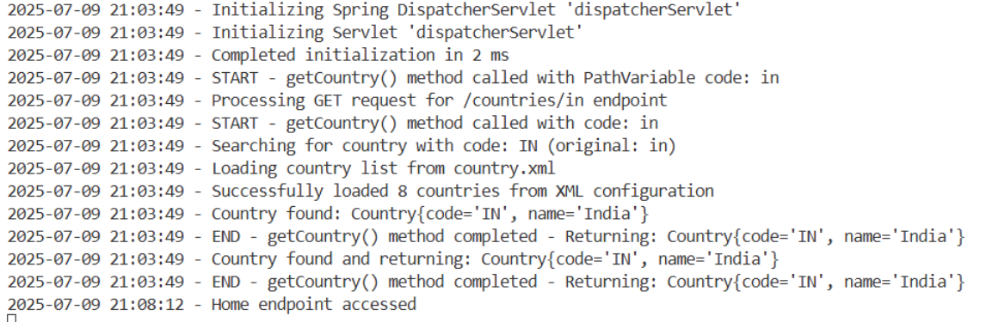

JWT-handson

Create authentication service that returns JWT

//XmlConfigController.java
package com.cognizant.springlearn.controller;

import java.text.SimpleDateFormat;
import java.util.Date;

import org.slf4j.Logger;
import org.slf4j.LoggerFactory;
import org.springframework.context.ApplicationContext;
import org.springframework.context.support.ClassPathXmlApplicationContext;
import org.springframework.web.bind.annotation.GetMapping;
import org.springframework.web.bind.annotation.RestController;

/**
* REST Controller to demonstrate Spring XML Configuration via web endpoints
*/
@RestController
public class XmlConfigController {

private static final Logger logger = LoggerFactory.getLogger(XmlConfigController.class);

/**
* Home endpoint showing XML configuration demo results
*/
@GetMapping("/")
public String home() {
logger.info("Home endpoint accessed - demonstrating XML configuration");

StringBuilder response = new StringBuilder();
response.append("<html><head><title>Spring XML Configuration Demo</title></head><body>");
response.append("<h1>Spring Core - Load SimpleDateFormat from Spring Configuration XML</h1>");
response.append("<h2>Demo Results:</h2>");

try {
// Create ApplicationContext from XML configuration
ApplicationContext context = new ClassPathXmlApplicationContext("date-format.xml");

// Get the dateFormat bean from Spring container
SimpleDateFormat format = context.getBean("dateFormat", SimpleDateFormat.class);

// Parse the string '31/12/2018' to Date class
String dateString = "31/12/2018";
Date parsedDate = format.parse(dateString);

response.append("<p><strong>Original date string:</strong> ").append(dateString).append("</p>");
response.append("<p><strong>Parsed Date object:</strong> ").append(parsedDate).append("</p>");
response.append("<p><strong>Formatted back to string:</strong> ").append(format.format(parsedDate)).append("</p>");
response.append("<p><strong>Date pattern used:</strong> dd/MM/yyyy</p>");
response.append("<p style='color: green;'><strong>✅ Successfully loaded SimpleDateFormat from Spring XML Configuration!</strong></p>");

response.append("<h3>XML Configuration (date-format.xml):</h3>");
response.append("<pre style='background-color: #f4f4f4; padding: 10px;'>");
response.append("&lt;?xml version=\"1.0\" encoding=\"UTF-8\"?&gt;\n");
response.append("&lt;beans xmlns=\"http://www.springframework.org/schema/beans\"\n");
response.append(" xmlns:xsi=\"http://www.w3.org/2001/XMLSchema-instance\"\n");
response.append(" xsi:schemaLocation=\"http://www.springframework.org/schema/beans\n");
response.append(" https://www.springframework.org/schema/beans/spring-beans.xsd\"&gt;\n\n");
response.append(" &lt;bean id=\"dateFormat\" class=\"java.text.SimpleDateFormat\"&gt;\n");
response.append(" &lt;constructor-arg value=\"dd/MM/yyyy\" /&gt;\n");
response.append(" &lt;/bean&gt;\n\n");
response.append("&lt;/beans&gt;");
response.append("</pre>");

} catch (Exception e) {
response.append("<p style='color: red;'><strong>❌ Error:</strong> ").append(e.getMessage()).append("</p>");
logger.error("Error in XML configuration demo: " + e.getMessage());
}

response.append("<h3>Other Endpoints:</h3>");
response.append("<ul>");
response.append("<li><a href='/health'>Health Check</a></li>");
response.append("<li><a href='/xml-demo'>XML Demo (JSON Response)</a></li>");
response.append("</ul>");

response.append("</body></html>");
return response.toString();
}

/**
* Health check endpoint
*/
@GetMapping("/health")
public String health() {
logger.info("Health check endpoint accessed");
return "Spring XML Configuration Demo Application is UP and running on port 8081!";
}

/**
* XML demo endpoint with JSON response
*/
@GetMapping("/xml-demo")
public String xmlDemo() {
logger.info("XML demo endpoint accessed");

try {
// Create ApplicationContext from XML configuration
ApplicationContext context = new ClassPathXmlApplicationContext("date-format.xml");

// Get the dateFormat bean from Spring container
SimpleDateFormat format = context.getBean("dateFormat", SimpleDateFormat.class);

// Parse the string '31/12/2018' to Date class
String dateString = "31/12/2018";
Date parsedDate = format.parse(dateString);

return "{\n" +
" \"demo\": \"Spring XML Configuration\",\n" +
" \"xmlFile\": \"date-format.xml\",\n" +
" \"beanId\": \"dateFormat\",\n" +
" \"beanClass\": \"java.text.SimpleDateFormat\",\n" +
" \"pattern\": \"dd/MM/yyyy\",\n" +
" \"originalString\": \"" + dateString + "\",\n" +
" \"parsedDate\": \"" + parsedDate + "\",\n" +
" \"formattedString\": \"" + format.format(parsedDate) + "\",\n" +
" \"status\": \"SUCCESS\"\n" +
"}";

} catch (Exception e) {
return "{\n" +
" \"demo\": \"Spring XML Configuration\",\n" +
" \"error\": \"" + e.getMessage() + "\",\n" +
" \"status\": \"ERROR\"\n" +
"}";
}
}
}
//SpringXmlConfigDemoApplication.java
package com.cognizant.springlearn;

import java.text.SimpleDateFormat;
import java.util.Date;

import org.slf4j.Logger;
import org.slf4j.LoggerFactory;
import org.springframework.boot.SpringApplication;
import org.springframework.boot.autoconfigure.SpringBootApplication;
import org.springframework.context.ApplicationContext;
import org.springframework.context.support.ClassPathXmlApplicationContext;

/**
* Main Spring Boot Application Class demonstrating XML Configuration
*/
@SpringBootApplication
public class SpringXmlConfigDemoApplication {

private static final Logger logger = LoggerFactory.getLogger(SpringXmlConfigDemoApplication.class);

public static void main(String[] args) {
logger.info("=================================================================");
logger.info("Spring Core - Load SimpleDateFormat from Spring Configuration XML");
logger.info("=================================================================");

// Demonstrate Spring XML Configuration with SimpleDateFormat
displayDate();

// Start the Spring Boot application
SpringApplication.run(SpringXmlConfigDemoApplication.class, args);

logger.info("=================================================================");
logger.info("Spring XML Configuration Demo completed successfully!");
logger.info("Application is running on: http://localhost:8081");
logger.info("=================================================================");
}

/**
* Method to demonstrate Spring XML Configuration for SimpleDateFormat
* This method loads the date-format.xml configuration and uses the dateFormat bean
*/
public static void displayDate() {
try {
// Create ApplicationContext from XML configuration
ApplicationContext context = new ClassPathXmlApplicationContext("date-format.xml");

// Get the dateFormat bean from Spring container
SimpleDateFormat format = context.getBean("dateFormat", SimpleDateFormat.class);

// Parse the string '31/12/2018' to Date class
String dateString = "31/12/2018";
Date parsedDate = format.parse(dateString);

// Display the result using System.out.println
System.out.println("Original date string: " + dateString);
System.out.println("Parsed Date object: " + parsedDate);
System.out.println("Formatted back to string: " + format.format(parsedDate));

logger.info("Successfully loaded SimpleDateFormat from Spring XML Configuration");
logger.info("Date pattern used: dd/MM/yyyy");
logger.info("Parsed date: " + parsedDate);

} catch (Exception e) {
logger.error("Error in displayDate() method: " + e.getMessage());
e.printStackTrace();
}
}
}

//index.html

<!DOCTYPE html>
<html>
<head>
<title>Spring XML Configuration Demo</title>
<style>
body { font-family: Arial, sans-serif; margin: 40px; }
.container { max-width: 800px; margin: 0 auto; }
.success { color: green; }
.code { background-color: #f4f4f4; padding: 10px; border-left: 4px solid #007acc; }
.endpoint { background-color: #e8f4fd; padding: 10px; margin: 10px 0; }
</style>
</head>
<body>
<div class="container">
<h1>Spring Core - Load SimpleDateFormat from Spring Configuration XML</h1>

<h2>Demo Overview</h2>
<p>This application demonstrates how to load SimpleDateFormat from Spring XML Configuration to avoid creating it in multiple places.</p>

<div class="endpoint">
<h3>Available Endpoints:</h3>
<ul>
<li><a href="/">Home (Dynamic XML Demo)</a></li>
<li><a href="/health">Health Check</a></li>
<li><a href="/xml-demo">XML Demo (JSON Response)</a></li>
</ul>
</div>

<h3>XML Configuration (date-format.xml):</h3>
<div class="code">
<pre>&lt;?xml version="1.0" encoding="UTF-8"?&gt;
&lt;beans xmlns="http://www.springframework.org/schema/beans"
xmlns:xsi="http://www.w3.org/2001/XMLSchema-instance"
xsi:schemaLocation="http://www.springframework.org/schema/beans
https://www.springframework.org/schema/beans/spring-beans.xsd"&gt;

&lt;bean id="dateFormat" class="java.text.SimpleDateFormat"&gt;
&lt;constructor-arg value="dd/MM/yyyy" /&gt;
&lt;/bean&gt;

&lt;/beans&gt;</pre>
</div>

<h3>Implementation Details:</h3>
<ul>
<li><strong>ApplicationContext:</strong> ClassPathXmlApplicationContext("date-format.xml")</li>
<li><strong>Bean Retrieval:</strong> context.getBean("dateFormat", SimpleDateFormat.class)</li>
<li><strong>Date Parsing:</strong> format.parse("31/12/2018")</li>
<li><strong>Pattern:</strong> dd/MM/yyyy</li>
</ul>

<div class="success">
<p><strong>✅ Benefits:</strong></p>
<ul>
<li>Single SimpleDateFormat instance defined in XML</li>
<li>Reusable across multiple classes</li>
<li>Centralized configuration management</li>
<li>Spring IoC container manages lifecycle</li>
</ul>
</div>

<p><em>Application running on port 8081</em></p>
</div>
</body>
</html>

//date-format.xml
<?xml version="1.0" encoding="UTF-8"?>
<beans xmlns="http://www.springframework.org/schema/beans"
xmlns:xsi="http://www.w3.org/2001/XMLSchema-instance"
xsi:schemaLocation="http://www.springframework.org/schema/beans
https://www.springframework.org/schema/beans/spring-beans.xsd">

<bean id="dateFormat" class="java.text.SimpleDateFormat">
<constructor-arg value="dd/MM/yyyy" />
</bean>

</beans>

//DateFormatDemo.java
package com.cognizant.springlearn;

import java.text.SimpleDateFormat;
import java.util.Date;

import org.springframework.context.ApplicationContext;
import org.springframework.context.support.ClassPathXmlApplicationContext;

/**
* Demonstration class showing how to load SimpleDateFormat from Spring XML Configuration
*/
public class DateFormatDemo {

public static void main(String[] args) {
System.out.println("=================================================================");
System.out.println("Spring Core - Load SimpleDateFormat from Spring Configuration XML");
System.out.println("=================================================================");

displayDate();

System.out.println("=================================================================");
System.out.println("Demo completed successfully!");
System.out.println("=================================================================");
}

/**
* Method to demonstrate Spring XML Configuration for SimpleDateFormat
* This method loads the date-format.xml configuration and uses the dateFormat bean
*/
public static void displayDate() {
try {
// Create ApplicationContext from XML configuration
ApplicationContext context = new ClassPathXmlApplicationContext("date-format.xml");

// Get the dateFormat bean from Spring container
SimpleDateFormat format = context.getBean("dateFormat", SimpleDateFormat.class);

// Parse the string '31/12/2018' to Date class
String dateString = "31/12/2018";
Date parsedDate = format.parse(dateString);

// Display the result
System.out.println("Original date string: " + dateString);
System.out.println("Parsed Date object: " + parsedDate);
System.out.println("Formatted back to string: " + format.format(parsedDate));

System.out.println("Successfully loaded SimpleDateFormat from Spring XML Configuration");
System.out.println("Date pattern used: dd/MM/yyyy");
System.out.println("Parsed date: " + parsedDate);

} catch (Exception e) {
System.err.println("Error in displayDate() method: " + e.getMessage());
e.printStackTrace();
}
}
}

//pom.xml

<?xml version="1.0" encoding="UTF-8"?>
<project xmlns="http://maven.apache.org/POM/4.0.0" xmlns:xsi="http://www.w3.org/2001/XMLSchema-instance"
xsi:schemaLocation="http://maven.apache.org/POM/4.0.0 https://maven.apache.org/xsd/maven-4.0.0.xsd">
<modelVersion>4.0.0</modelVersion>
<parent>
<groupId>org.springframework.boot</groupId>
<artifactId>spring-boot-starter-parent</artifactId>
<version>3.2.0</version>
<relativePath/> <!-- lookup parent from repository -->
</parent>
<groupId>com.cognizant</groupId>
<artifactId>spring-xml-config-demo</artifactId>
<version>0.0.1-SNAPSHOT</version>
<name>spring-xml-config-demo</name>
<description>Spring Core - Load SimpleDateFormat from Spring Configuration XML</description>
<properties>
<java.version>17</java.version>
</properties>
<dependencies>
<!-- Spring Boot Starter Web -->
<dependency>
<groupId>org.springframework.boot</groupId>
<artifactId>spring-boot-starter-web</artifactId>
</dependency>

<!-- Spring Boot DevTools -->
<dependency>
<groupId>org.springframework.boot</groupId>
<artifactId>spring-boot-devtools</artifactId>
<scope>runtime</scope>
<optional>true</optional>
</dependency>

<!-- Spring Boot Test Starter -->
<dependency>
<groupId>org.springframework.boot</groupId>
<artifactId>spring-boot-starter-test</artifactId>
<scope>test</scope>
</dependency>
</dependencies>

<build>
<plugins>
<plugin>
<groupId>org.springframework.boot</groupId>
<artifactId>spring-boot-maven-plugin</artifactId>
</plugin>
</plugins>
</build>

</project>

OUTPUT:

